Adding Product Search

Search is an essential part of any ecommerce application. If you don’t believe me, go to [https://amazon.com](https://amazon.com/). How hard is it to find the search box? Pretty easy right.

If search is essential, we probably need to make a pretty good search, right? Our current ecommerce application doesn’t support search. Now we could use just SQL statements to query the product table, but that won’t be a great option. SQL like statements won’t find misspelled words or do many other things we would expect from a search system.

How should we go about adding search to our application? We could use something like full text search in the database. That might work for very basic use cases, but there are better options out there. For this activity we are going to use Lucene.net to do the searches. Lucene.net is an open source search library based off of a java version called Lucene.

At DPL we have used Lucene on a few projects. The great thing about Lucene is that it is pretty light-weight for a search solution. No services to setup. No web server to setup. No Java to install.

But before we jump into code lets discuss the change we are going to make to the system. We want to add search to our system. Our current architecture doesn't have search, we will need to extend our architecture to support search.

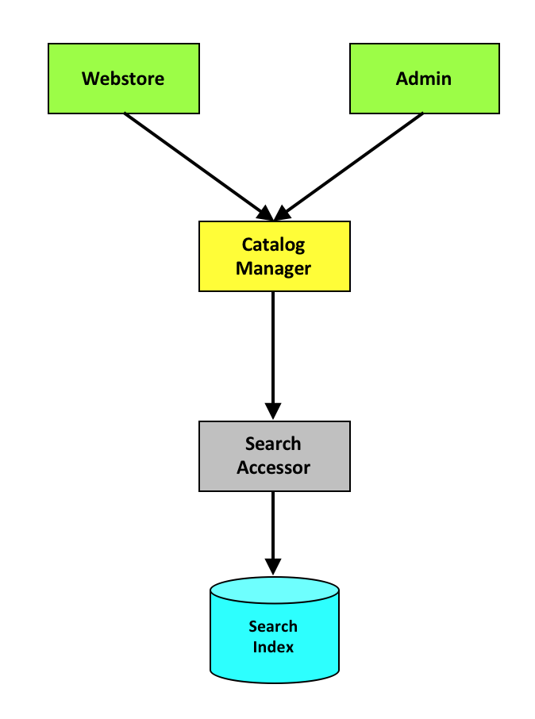

Where do we start? At the beginning, of course.

Add a NuGet package reference to Lucene.net to our accessors project.



Configuration for where Lucene should write it’s index files is already in place with the IndexPath property on the. Config class.

public static string IndexPath

{

get

{

return GetConfigValue("eCommerceIndexPath", "SearchIndex");

}

}

Start by building out the definition for the SearchAccessor.

public interface ISearchAccessor : IServiceContractBase

{

void RebuildIndex(int catalog);

Product[] Search(int catalogId, string text);

}

Create a SearchAccessor that implements ISearchAccessor.

class SearchAccessor : AccessorBase, ISearchAccessor

Update dependency injection to support calling the SearchAccessor. You will have to make that change in the AccessorFactory.

AddType<ISearchAccessor>(typeof(SearchAccessor));

Implement the RebuildIndex method in SearchAccessor.

public void RebuildIndex(int catalogId)

{

if (System.IO.Directory.Exists(GetIndexDirectory().FullName))

System.IO.Directory.Delete(GetIndexDirectory().FullName, true);

using (var analyzer = new SimpleAnalyzer(LuceneVersion.LUCENE_48))

using (var indexDir = FSDirectory.Open(GetIndexDirectory()))

{

var config = new IndexWriterConfig(Lucene.Net.Util.LuceneVersion.LUCENE_48, analyzer);

using (var indexWriter = new IndexWriter(indexDir, config))

{

using (var db = eCommerce.Accessors.EntityFramework.eCommerceDbContext.Create())

{

foreach (var p in db.Products.Where(p => p.CatalogId == catalogId))

{

var doc = new Document();

doc.Add(new Int32Field("Id", p.Id, Field.Store.YES));

doc.Add(new TextField("Name", p.Name, Field.Store.YES));

indexWriter.AddDocument(doc);

}

}

}

}

}

Implement the Search method in SearchAccessor.

public Product[] Search(int catalogId, string text)

{

var result = new List<Product>();

using (var analyzer = new SimpleAnalyzer(LuceneVersion.LUCENE_48))

using (var indexDirectory = FSDirectory.Open(GetIndexDirectory()))

using(var indexReader = DirectoryReader.Open(indexDirectory))

{

var query = new FuzzyQuery(new Term("Name", text), 2);

var indexSearcher = new IndexSearcher(indexReader);

var searchResults = indexSearcher.Search(query, 10).ScoreDocs;

foreach (var searchResultItem in searchResults)

{

var doc = indexSearcher.Doc(searchResultItem.Doc);

var product = new Product()

{

Id = (int)doc.GetField("Id")?.GetInt32Value(),

Name = doc.GetField("Name")?.GetStringValue()

};

result.Add(product);

}

return result.ToArray();

}

}

The above code assumes you will have a GetIndexDirectory method in SearchAccessor.

rivate DirectoryInfo GetIndexDirectory()

{

if (!string.IsNullOrWhiteSpace(IndexPath))

{

var dir = new DirectoryInfo(IndexPath);

if (dir.Exists)

return dir;

}

throw new InvalidOperationException("eCommerceIndexPath is not configured.");

}

Next, we will have to write the actual code to do the searching. This code should be pretty straight-forward too.

public Product[] Search(int catalogId, string text)

{

var result = new List<Product>();

using (var analyzer = new SimpleAnalyzer(LuceneVersion.LUCENE_48))

using (var indexDirectory = FSDirectory.Open(GetIndexDirectory()))

using(var indexReader = DirectoryReader.Open(indexDirectory))

{

var query = new FuzzyQuery(new Term("Name", text), 2);

var indexSearcher = new IndexSearcher(indexReader);

var searchResults = indexSearcher.Search(query, 10).ScoreDocs;

foreach (var searchResultItem in searchResults)

{

var doc = indexSearcher.Doc(searchResultItem.Doc);

var product = new Product()

{

Id = (int)doc.GetField("Id")?.GetInt32Value(),

Name = doc.GetField("Name")?.GetStringValue()

};

result.Add(product);

}

return result.ToArray();

}

}

Once we have those in place we need to add some unit tests for the SearchAccessor. Take a few minutes and write a unit test for the SearchAccessor.

[TestMethod]

[TestCategory("Accessor Tests")]

public void SearchAccessor_BasicSearchTest()

{

}

Next, update the catalog manager level to support calling our new search accessor. Add a new method to CatalogManager to perform this search, and a method to rebuild the index. These two methods will be broken across two interfaces.

IWebStoreCatalogManager

/// <summary>

/// Search a webstore catalog

/// </summary>

/// <param name="catalogId"></param>

/// <returns></returns>

WebStoreSearchResponse Search(int catalogId, string query);

IAdminCatalogManager

/// Rebuild search catalog

/// </summary>

void RebuildCatalog(int catalogId);

This solution will require a few new DTOs.

[DataContract]

public class ProductSearchItem

{

[DataMember]

public int Id { get; set; }

[DataMember]

public string Name { get; set; }

[DataMember]

public decimal Price { get; set; }

}

[DataContract]

public class WebStoreSearchResponse : ResponseBase

{

[DataMember]

public ProductSearchItem[] Products { get; set; }

}

Now go through and implement the two manager methods. They should be pretty basic methods.

public void RebuildCatalog(int catalogId)

{

try

{

AccessorFactory.CreateAccessor<ISearchAccessor>().RebuildIndex(catalogId);

}

catch(Exception ex)

{

Logger.Error(ex);

}

}

WebStore.WebStoreSearchResponse WebStore.IWebStoreCatalogManager.Search(int catalogId, string query)

{

try

{

var products = AccessorFactory.CreateAccessor<ISearchAccessor>().Search(catalogId, query);

var list = new List<WebStore.ProductSearchItem>();

foreach(var product in products)

{

var searchProduct = new WebStore.ProductSearchItem()

{

Id = product.Id,

Name = product.Name,

Price = product.Price

};

list.Add(searchProduct);

}

return new WebStore.WebStoreSearchResponse()

{

Success = true,

Products = list.ToArray(),

};

}

catch (Exception ex)

{

Logger.Error(ex);

return new WebStore.WebStoreSearchResponse() { Success = false };

}

}

We should also add a few unit tests for this code. But for the purpose of this walkthrough, lets write a single integration test.

[TestMethod]

[TestCategory("Managers-WebStore")]

public void CatalogManager_Search()

{

// ## Arrange ##

// Create managers

var context = new AmbientContext() { SellerId = 1, SessionId = Guid.NewGuid(), AuthToken = "MyToken" };

var webStoreMgr = GetManager<IWebStoreCatalogManager>(context);

var adminMgr = GetManager<DPLRef.eCommerce.Contracts.Admin.Catalog.IAdminCatalogManager>(context);

// Create a catalog using admin manager

var saveCatalogResponse = adminMgr.SaveCatalog(new DPLRef.eCommerce.Contracts.Admin.Catalog.WebStoreCatalog()

{

Name = "integration_test",

Description = "integration_test"

});

// Save a product using admin manager

var saveProductResponse = adminMgr.SaveProduct(

saveCatalogResponse.Catalog.Id,

new DPLRef.eCommerce.Contracts.Admin.Catalog.Product()

{

Name = "hello world",

IsAvailable = true,

Price = 10.0m,

});

// ## Act ##

// Rebuild catalog using admin manager

// Search using web store manager

// ## Assert ##

}

Last, we need to update our webstore UI to support our new search interfaes added to our CatalogManager. To accomplish this, we will need to update our program.cs file.

Around line 110

case 17: // Rebuild Search

RebuildSearch(1);

break;

case 18:

Search(1);  
 break;

Arround line 156

Console.WriteLine("Search =====================");

Console.WriteLine(" 17: Rebuild Search");  
Console.WriteLine(" 18: Search");

Add RebuildSearch and Search methods to class Program.

// Rebuild Search calls the admin contract

// I included it here to make working with this code easier.

private static void RebuildSearch(int catalogId)

{

var context = new AmbientContext() { SellerId = 1 };

var managerFactory = new ManagerFactory(context);

var webStoreCatalogManager = managerFactory.CreateManager<Contracts.Admin.Catalog.IAdminCatalogManager>();

webStoreCatalogManager.RebuildCatalog(catalogId);

}

private static void Search(int catalogId)

{

Console.WriteLine("Search Text:");

var query = Console.ReadLine();

var context = new AmbientContext() { SellerId = 1 };

var managerFactory = new ManagerFactory(context);

var webStoreCatalogManager = managerFactory.CreateManager<IWebStoreCatalogManager>();

var response = webStoreCatalogManager.Search(catalogId, query);

ShowResponse(response, StringUtilities.DataContractToJson<ProductSearchItem[]>(response.Products));

}

This activity is a great example of how our architecture could be extended with minimal effort. We were able to extend the system by only changing one existing architecture piece (CatalogManager). And the change to CatalogManger was only an extension. We added a new SearchAccessor that hid the dependency of Lucene. Based off of our implementation, we should be able to change our search technology, without changing anything else in the system.